- Compress a file by compress, gzip, zip commands and decompress it again. State the differences between compress and gzip commands.
- compress & uncompress
- gzip & gunzip
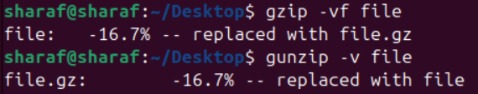
- zip & unzip
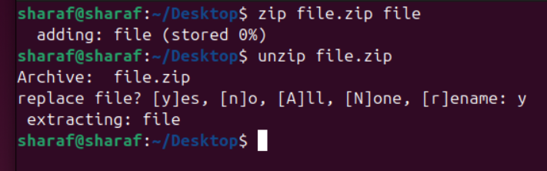
compress | gzip | zip
Compress only one file at time | Compress one file at time (multiple file need tar) | Compress and Archiving
Low eff | High eff | Moderate eff
- What is the command used to view the content of a compressed file.
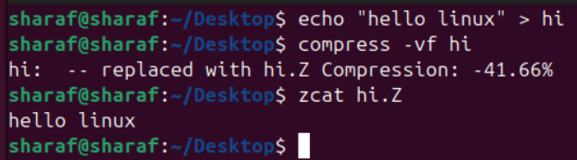
- Backup /etc directory using tar utility.

- tarting from your home directory, find all files that were modified in the last two day.
n (exactly n ago) / -n (less than n ago) / +n (more than n ago)
- Starting from /etc, find files owned by root user.
- Find all directories in your home directory.
- Write a command to search for all files on the system that, its name is “.profile”.
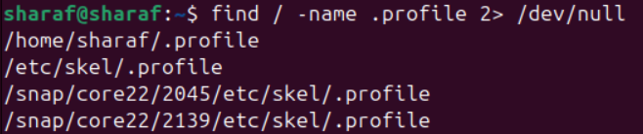
- Identify the file types of the following: /etc/passwd, /dev/pts/0, /etc, /dev/sda.
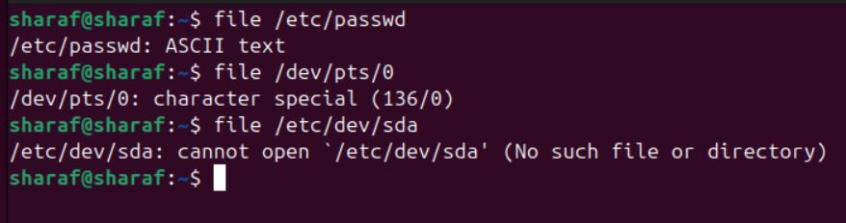
- List the inode numbers of /, /etc, /etc/hosts.
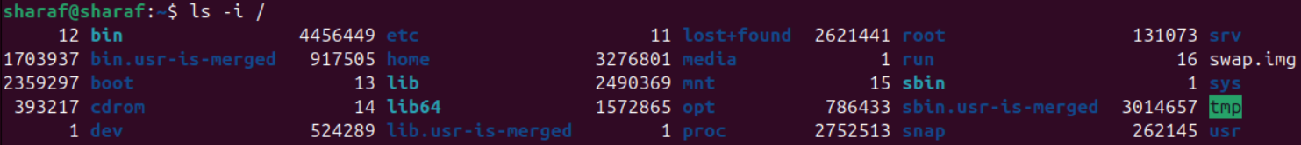
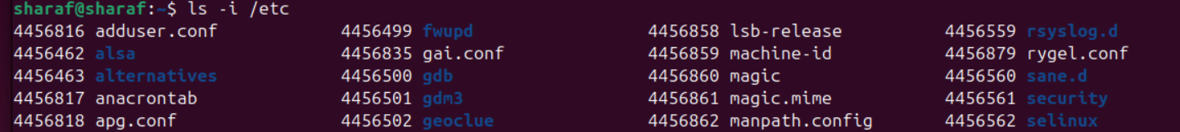
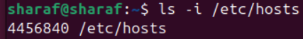

- Copy /etc/passwd to your home directory, use the commands diff and cmp, and Edit in the file you copied, and then use these commands again, and check the output.
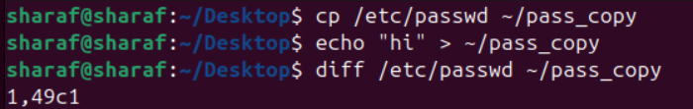
diff | cmp
Show line differences | Show first byte difference
- Create a symbolic link of /etc/passwd in /boot.
- Create a hard link of /etc/passwd in /boot. Could you? Why?
- Not Same Partitions



